Lab Practical #13:
  - To develop network using distance vector routing protocol and link state routing protocol.

Practical Assignment #13:

C/Java Program: Distance Vector Routing Algorithm using Bellman Ford's Algorithm.
import java.util.*;

public class DistanceVectorRouting {
private static final int INF = 9999;

public static void main(String[] args) {
Scanner scanner = new Scanner(System.in);

System.out.print("Enter the number of routers: ");
int numRouters = scanner.nextInt();

int[][] costMatrix = new int[numRouters][numRouters];
System.out.println("Enter the cost matrix (use " + INF + " for infinity):");
for (int i = 0; i < numRouters; i++) {
for (int j = 0; j < numRouters; j++) {
costMatrix[i][j] = scanner.nextInt();
}
}

int[][] distanceVector = new int[numRouters][numRouters];
int[][] nextHop = new int[numRouters][numRouters];

for (int i = 0; i < numRouters; i++) {
for (int j = 0; j < numRouters; j++) {
distanceVector[i][j] = costMatrix[i][j];
nextHop[i][j] = (costMatrix[i][j] != INF && i != j) ? j : -1;
}
}

boolean updated;
do {
updated = false;
for (int i = 0; i < numRouters; i++) {
for (int j = 0; j < numRouters; j++) {
for (int k = 0; k < numRouters; k++) {
if (distanceVector[i][k] + distanceVector[k][j] < distanceVector[i][j]) {
distanceVector[i][j] = distanceVector[i][k] + distanceVector[k][j];
nextHop[i][j] = nextHop[i][k];
updated = true;
}
}
}
}
} while (updated);

System.out.println("\nFinal Distance Vector Table:");
for (int i = 0; i < numRouters; i++) {
System.out.println("Router " + (i + 1) + ":");
for (int j = 0; j < numRouters; j++) {
if (distanceVector[i][j] == INF) {
System.out.print("INF ");
} else {
System.out.print((distanceVector[i][j] + 1) + " ");
}
}
System.out.println();
}

scanner.close();
}
}

Output:
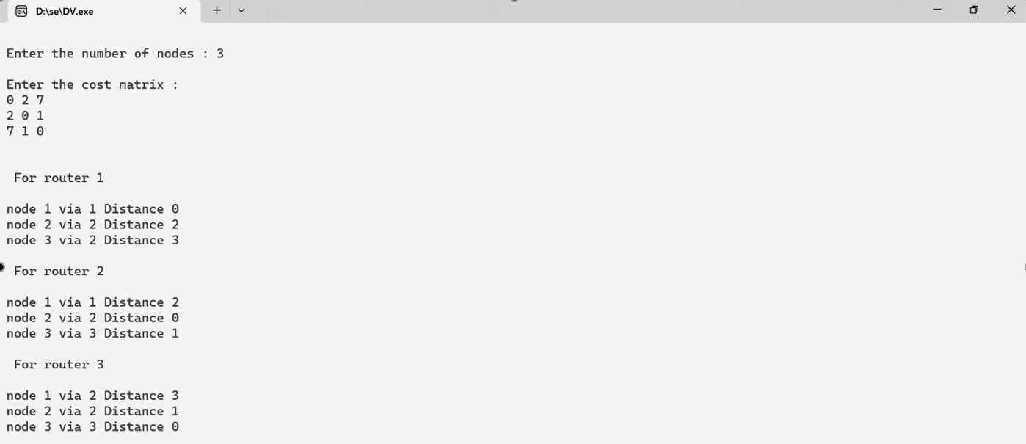

C/Java Program: Link state routing algorithm.
import java.util.*;

public class LinkStateRouting {
private static final int INF = 9999;

private static int minDistance(int[] dist, boolean[] visited, int n) {
int min = INF, minIndex = -1;
for (int v = 0; v < n; v++) {
if (!visited[v] && dist[v] < min) {
min = dist[v];
minIndex = v;
}
}
return minIndex;
}

private static void printPath(int[] prev, int j) {
if (prev[j] == -1) {
System.out.print((j + 1));
return;
}
printPath(prev, prev[j]);
System.out.print(" -> " + (j + 1));
}

public static void main(String[] args) {
Scanner scanner = new Scanner(System.in);

System.out.print("Enter the number of routers: ");
int numRouters = scanner.nextInt();

int[][] costMatrix = new int[numRouters][numRouters];
System.out.println("Enter the cost matrix (use " + INF + " for infinity):");
for (int i = 0; i < numRouters; i++) {
for (int j = 0; j < numRouters; j++) {
costMatrix[i][j] = scanner.nextInt();
}
}

for (int src = 0; src < numRouters; src++) {
int[] dist = new int[numRouters];
int[] prev = new int[numRouters];
boolean[] visited = new boolean[numRouters];

Arrays.fill(dist, INF);
Arrays.fill(prev, -1);

dist[src] = 0;

for (int count = 0; count < numRouters - 1; count++) {
int u = minDistance(dist, visited, numRouters);
if (u == -1) break;
visited[u] = true;

for (int v = 0; v < numRouters; v++) {
if (!visited[v] && costMatrix[u][v] != INF && dist[u] != INF &&
dist[u] + costMatrix[u][v] < dist[v]) {
dist[v] = dist[u] + costMatrix[u][v];
prev[v] = u;
}
}
}

System.out.println("\nRouting Table for Router " + (src + 1) + ":");
System.out.println("Destination\tCost\tPath");
for (int dest = 0; dest < numRouters; dest++) {
if (dist[dest] == INF) {
System.out.println((dest + 1) + "\t\tINF\tNo path");
} else {
System.out.print((dest + 1) + "\t\t" + dist[dest] + "\t");
printPath(prev, dest);
System.out.println();
}
}
}

scanner.close();
}
}

Output:
